ספר הפרויקט
יוגש באתר הקורס ב MOODLE (לאחר אישור המנחה) עד לתאריך שפורסם.
הגשת ספר הפרויקט בזמן – סטודנטים שלא יגישו בזמן ולפי ההנחיות, לא יוכלו להציג את הפרויקט במועד שנקבע ויצטרכו לתאם מועד חדש.
ספר הפרויקט מסכם את עבודת הסטודנטים בפרויקט.
ספר הפרויקט יכלול את הפרקים הבאים:
  - תקציר (עמוד אחד)
  - הקדמה ורקע תיאורטי
  - תכנון ו\או סימולציה
  - מימוש
  - תוצאות ובדיקות (עם דגש לדרישות הכמותיות)
  - סיכום, מסקנות והצעות להמשך
  - תיעוד הפרויקט
  - רשימת מקורות (כמקובל בספרות מדעית)
יש להיוועץ עם המנחה בפרויקט, על מנת להבין, איזה פרקים יש לכלול בספר הפרויקט בהתאם לאופיו של הפרויקט שלכם.
יש להגיש את הספר, לפי התבנית המצורפת.
ניתן להגיש את הספר באנגלית, תוך הקפדה על התבנית. גודל הקובץ הוא לכל היותר 10 מגה.
סדר הגודל המומלץ לספר הפרויקט הוא 20 עמודים.
ספר הפרויקט לא יכלול את קטעי הקוד ,דפי נתונים וכו'. במידה ויש התייחסות ספציפית בספר הפרויקט לחלק מהקוד או דפי הנתונים וכו', ניתן לצרף את החומר הרלוונטי בלבד וכנספח לספר הפרויקט.



Insert the Project Title here

Project Number:

Project Report

Student: |  | ID:
Student: |  | ID:

Supervisor:

Project Carried Out at:

Contents
Abstract……….. 2
1 Introduction 3
2 Theoretical background 4
3 Simulation.. 5
4 Implementation 6
4.1 Hardware Description 6
4.2 Software Description 7
5 Analysis of results 8
6 Conclusions and further work 9
7 Project Documentation 10
8 References.. 11
Appendix A. Subject 1 12
Appendix B Subject 2 13

List of figures
Figure 1: Block diagram 2
Figure 2: The System 6
Figure 3: Amplifier Input Circuit 6

List of tables
Table 1: Results 8

List of equations

Abstract
The abstract summarizes the essence of the work (project topic, project purpose, and project deliverable). Further to the description, a block diagram of the project should be presented .
Figure 1: Block diagram

The chapters, illustrations and tables should be numbered automatically, as done here. The Table of Contents should also be generated.
Figures and illustrations can be generated either from a POWERPOINT slide (as done here) or added (JPG, TIFF, BMP) as done in Chapter 4, or from a PDF document as done in Subsection 4.1.
An example of the table can be seen in subchapter 5.1.

Introduction
This chapter will outline:
- The goals of the project
- Motivation
- The approach to solving the problem
- Comparison against existing work and algorithms / implementations on the topic

Theoretical background
In this section, the theoretical background and relevant algorithms will be described. Alternative algorithms for project implementation should also be referenced.

Simulation
In this chapter the simulation environment will be described.
Simulation results will be presented.

Implementation
In this chapter, the implementation and considerations for its choice will be described. The chapter should include a general description, including a detailed block diagram, for how the project is being implemented.
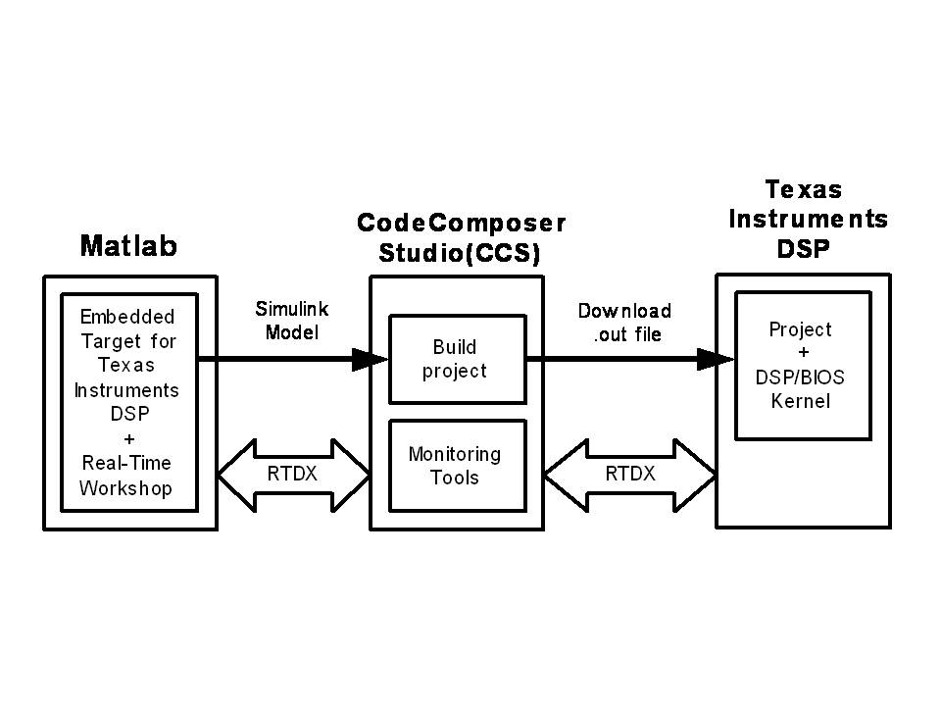
Figure 2: The System

Hardware Description
A description of components, tools, platforms and systems used in the project implementation, including appropriate diagrams.
Figure 3: Amplifier Input Circuit

Software Description
A description of the software implementation, including details of the tools, platforms and relevant explanations. Printouts of the code should not be included.

Analysis of results
Comparisons of simulation results to real-time work (as well as simulations for the alternative algorithms presented in the theoretical background section, if real-time realization is not yet available, alternative algorithms must be compared).

Table 1: Results
 | Parameter | Simulation | Real Time | Alternative Algorithm
 | Gain | 8 dB | 7.5 dB | 7 dB
 | Noise Level | -30 dBm | -50 dBm | -58 dBm

Conclusions and further work
This is the most important chapter. This section should include:
- Examining the project results against the goals set in the first place
- Suggestions to improve system performance
- Possibilities for future (development / research) activities

Project Documentation
All project deliverables are to be documented (e.g. GitHub), this final project report should only include their description:
- Description of the project documentation (Hardware, software, additional simulations, user guide, etc.)
- The Documentation location (e.g. the GitHub link)
- Description of the project files

References
Here are some examples of references, and how they should be included.
Books:
- A. M. Bronstein, M. M. Bronstein, and R. Kimmel. "Numerical geometry of non-rigid shapes”, Springer-Verlag New York Inc, 2008.
Papers:
- G. B. Giannakis , "Highlights of Signal Processing for Communications", IEEE Signal Processing Magazine, Vol. 16, no 2, pp. 14-49, March 1999
Datasheet
- “Spartan-3A DSP FPGA Family Data Sheet”, XILINX Product Specification DS610, October 4, 2010. http://www.xilinx.com/support/documentation/data_sheets/ds610.pdf
Application Note :
- X. Zhang, "Developing a CCStudio 2.0 DSP/BIOS Application for FLASH Booting on the TMS320C5402 DSK", TI Application Report SPRA661A, November 2000. http://www.ti.com/lit/an/spra661a/spra661a.pdf
User's Guide:
- "TMS320C6201/6701 Evaluation Module User's Guide", SPRU269F, August 2002
- Code Composer Studio IDE 2.0 online help.
Links:
- "Dolby E Multichannel Coding for DTV Audio Production and Distribution", http://www.dolby.com/tech/m.br.9903.epaper.pdf
- G. Welch and G. Bishop – "An Introduction to the Kalman Filter", http://www.cs.unc.edu/~welch/kalman/kalman_filter/kalman.html#pgfId-11854
- C. Mercer, "Smoothing Spectral Data", The PROSIG Digital Signal Processing Tutorials, http://www.prosig.com/signal-processing/smoothingspectra.html

- Subject 1
If you need to go into details of a specific subject, you should do it here.
A dedicated appendix should be included for each subject.

- Subject 2

A single page length at most.
The abstract should allow a person who does not read all chapters of the project book to have a complete picture of the nature of the work.
Notice the insertion of the FOOTNOTE, and the links from this page to the chapters in which the examples appear.
If applicable
If relevant

